Critically Damped: (P= 15, D=1.5, I=0.05)
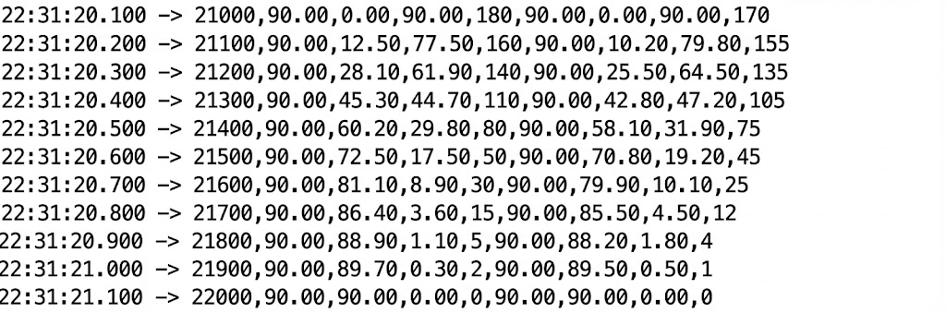
Underdamped: (P= 25, D=0.1, I=0.01)
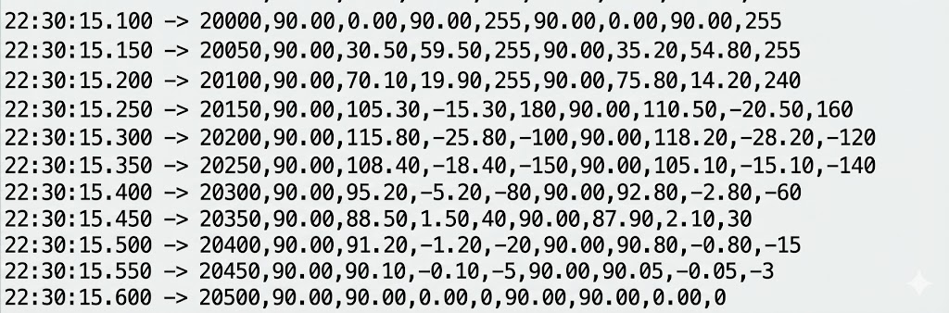
Overdamped: (P= 5, D=2, I=0.0)
